Name: Mark Rexan Magnanao
Section: DIT 3A

Results at a Glance
Challenge | What I changed | Best result (test)
1. Tree depth | Depth 1, 3, 8 | Depth 8: 95.6% accuracy
2. Minimum samples per leaf | Leaf size 1, 5, 15 | Leaf 5: 96.3% accuracy
3. Dataset noise | Noise 0.22 to 0.38 | Accuracy fell to 86.7%
4. Confusion matrix | Depth 2 vs 8 | Depth 8: 10 to 3 false positives
5. Regression | Depth 2, 4, 10 | Depth 4: lowest test error (0.280)

Challenge 1: Tree depth
Deeper trees split the data into more, smaller regions. Depth 1 was too simple (80.7% test accuracy), depth 3 gave 90.4%, and depth 8 gave 95.6%. Depth 8 had the highest training accuracy too, but the test result is what matters here.

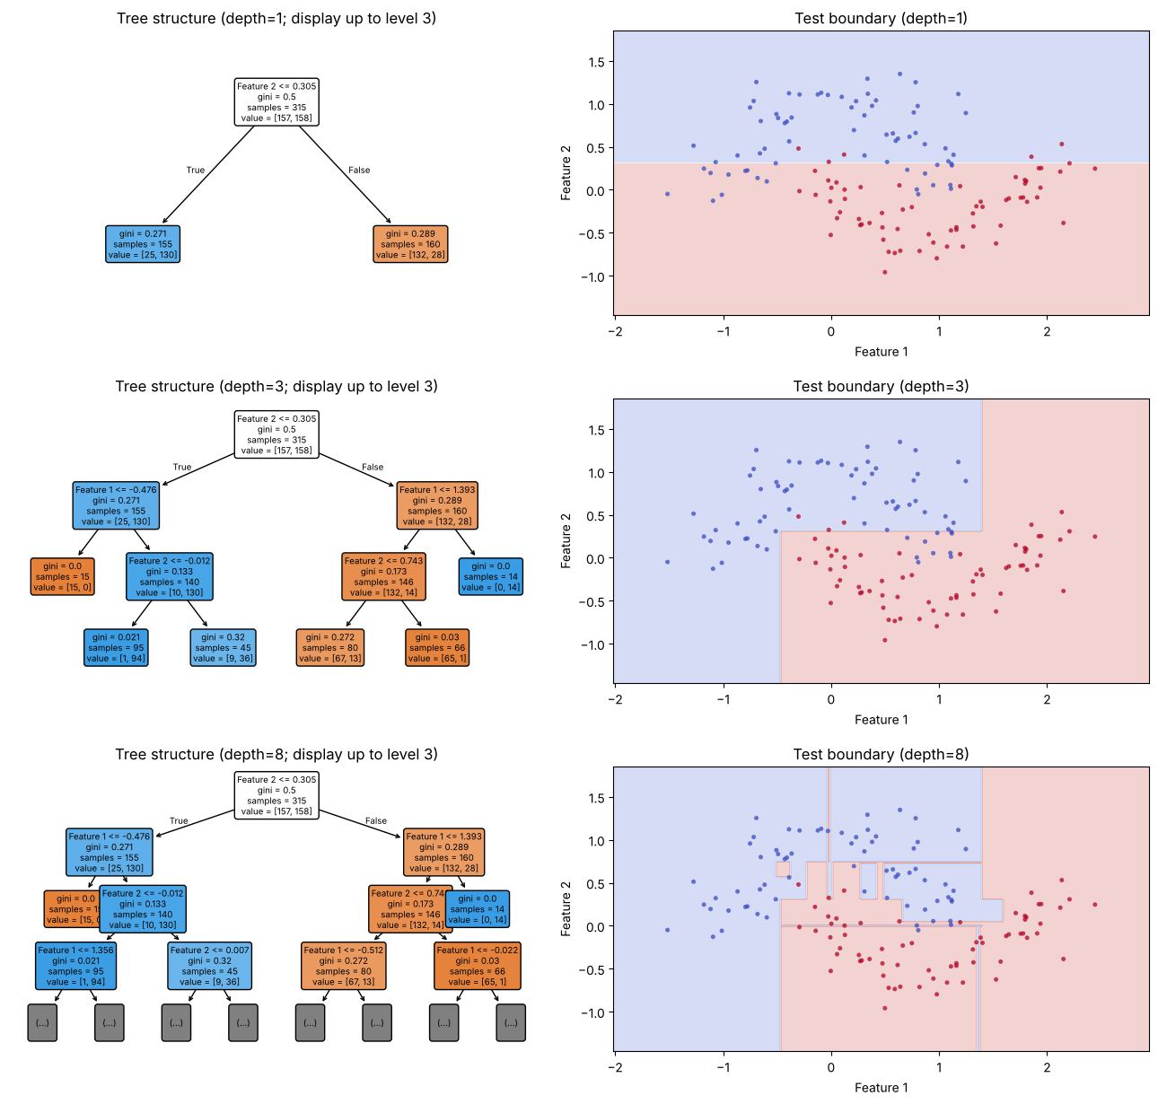
Figure: test decision boundaries at depth 1, 3 and 8 (top to bottom)

Challenge 2: Minimum samples per leaf
A larger minimum leaf size makes the tree simpler. Leaf size 5 scored slightly higher on test data (96.3% vs 95.6%), but that is only one extra correct prediction. Leaf size 15 was too simple and scored 91.1%.

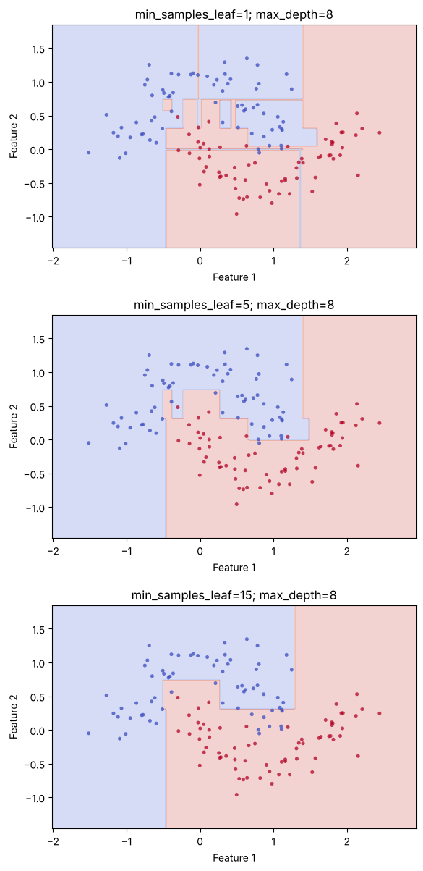
Figure: test boundaries at leaf sizes 1, 5 and 15 (top to bottom)

Challenge 3: Dataset noise
Raising the noise made the two classes overlap more, and test accuracy dropped from 90.4% to 86.7%. Some errors cannot be avoided when the classes overlap, so this drop is expected.

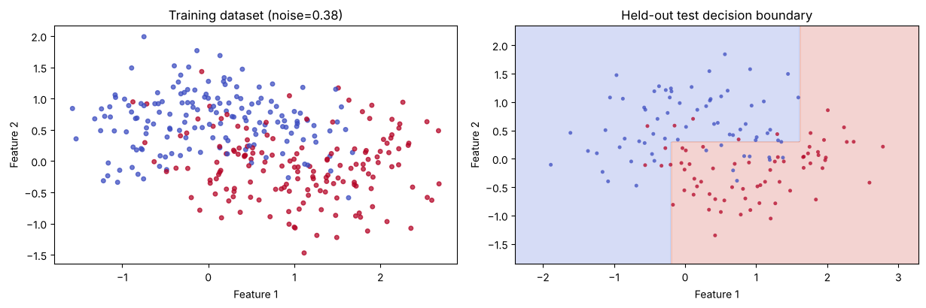
Figure: noise 0.38 training data and test boundary

Challenge 4: Confusion matrix
Depth 2 and depth 8 both missed 3 class-1 samples, but depth 2 wrongly flagged 10 class-0 samples while depth 8 flagged only 3. Depth 8 is the better model here, with 95.6% accuracy compared with 90.4%.

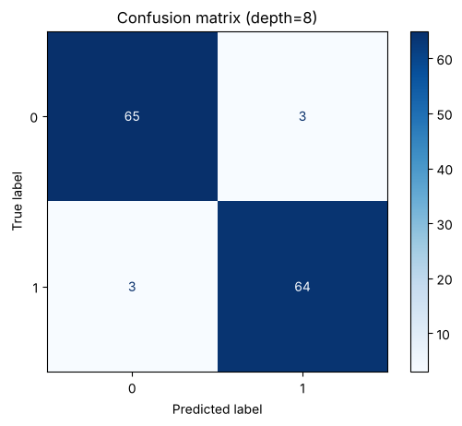
Figure: confusion matrix at depth 8

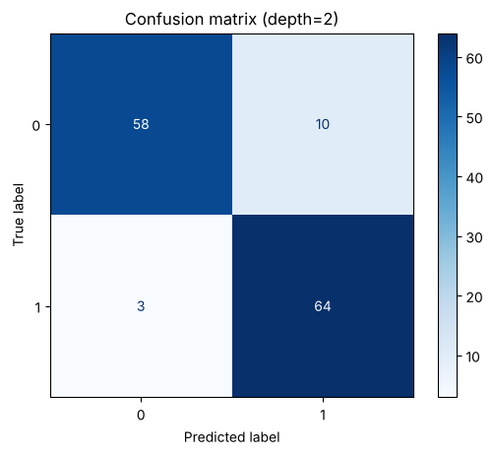
Figure: confusion matrix at depth 2

Challenge 5: Regression
Depth 2 was too simple (test error 0.380). Depth 4 gave the lowest test error (0.280). Depth 10 fit the training data best (0.036) but predicted new data worse (0.296), so the lowest training error did not give the best result.

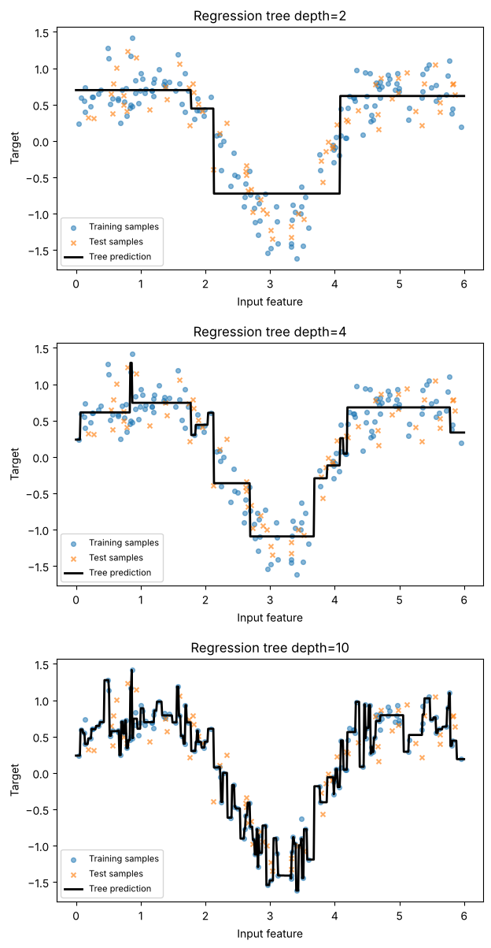
Figure: regression curves at depth 2, 4 and 10 (top to bottom)

Caveat
These results come from a single train/test split with only 135 test samples, so small differences are not conclusive. Cross-validation would give a more reliable choice.

